Speech-Based Computational Analysis of Striatal and Basal Ganglia Dysfunction in Parkinson’s Disease Using Classical and Hybrid Quantum Machine Learning

¹Dr.Siddique Ibrahim S P
School of Computer Science and Engineering
VIT-AP University,
Amaravati, Andhra Pradesh, India
siddique.ibrahim@vitapstudent.ac.in

²Karthikeyan Bharadwaj S
School of Computer Science and Engineering
VIT-AP University
Amaravati, Andhra Pradesh, India
karthikeyan.22bce9112@vitapstudent.ac.in

⁴Sai Kushal Vittanala
School of Computer Science and Engineering
VIT-AP University
Amaravati, Andhra Pradesh, India
kushal.22bce9529@vitapstudent.ac.in
³Naga Lahari T
School of Computer Science and Engineering
VIT-AP University
Amaravati, Andhra Pradesh, India
lahari.22bce7250@vitapstudent.ac.in

Abstract—Parkinson’s disease (PD) is a progressive neurode- generative disorder caused by dopamine depletion in the striatum, which disrupts basal ganglia–thalamocortical circuits responsible for motor timing, force regulation, and coordinated movement. Because speech production depends on precise motor control, early striatal dysfunction manifests as measurable acoustic abnormali- ties, making speech a reliable and non-invasive biomarker for PD detection. In this study, we propose a comprehensive speech-based computational framework to analyze basal ganglia dysfunction using both machine learning and hybrid quantum machine learning models. A total of 754 acoustic features were extracted from sustained phonation recordings to capture perturbation measures, nonlinear dynamics, spectral variations, and temporal instability associated with hypokinetic dysarthria. Machine learning models including PSO-SVM, Support Vector Machine, and XG- Boost were evaluated using stratified ten-fold cross-validation. To ensure a fair and controlled comparison with quantum models under current qubit limitations, Principal Component Analysis (PCA) was applied to reduce feature dimensionality. To enable a direct and controlled comparison between quantum and machine learning models on identical input representations, PCA-reduced features were also evaluated using machine learning models. The findings confirm that high-dimensional acoustic speech features effectively reflect striatal motor control deficits and demonstrate that, under present technological conditions, machine learning provides better practical performance while quantum machine learning remains a promising exploratory direction for future neurological assessment systems.
Keywords—Parkinson’s disease, basal ganglia, striatal dysfunc- tion, speech biomarkers, machine learning, quantum machine learning.
- Introduction
Parkinson’s disease is one of the most prevalent neurode- generative disorders worldwide, affecting approximately one to two percent of individuals over the age of sixty-five.
The disease arises from progressive loss of dopaminergic neurons in the substantia nigra pars compacta, which results in dopamine depletion within the striatum. The striatum serves as the primary input nucleus of the basal ganglia and plays a central role in regulating motor timing, amplitude scaling, and movement coordination. Dopamine depletion disrupts the balance between the direct and indirect pathways of the basal ganglia, leading to impaired motor control and the character- istic symptoms of Parkinson’s disease.
While Parkinson’s disease is traditionally diagnosed based on motor symptoms, the disease begins with non-motor symp- toms which develop in the beginning stages and continue to progress without detection. Hypokinetic dysarthria occurs in approximately seventy to ninety percent of people with Parkinson’s disease and shows five distinct vocal character- istics which include lower vocal loudness and unchanging pitch and unclear speech sounds and breathy voice quality and vocal fold vibration that shows greater instability. The speech disorders result from damaged neural pathways which control speech production instead of physical harm to the vocal cords. The speech impairment stands as one of the most frequently occurring clinical disabilities.
Human beings create spoken language through an intricate motor system that requires all three components of speech pro- duction to function simultaneously. This system uses striatal- basal ganglia-cortical loops to control its functions which guarantee exact timing and correct power delivery. Scientists can measure the first signs of striatal dysfunction which cause detectable changes in speech acoustics. These changes can be quantified using digital signal processing techniques and analyzed using machine learning methods.

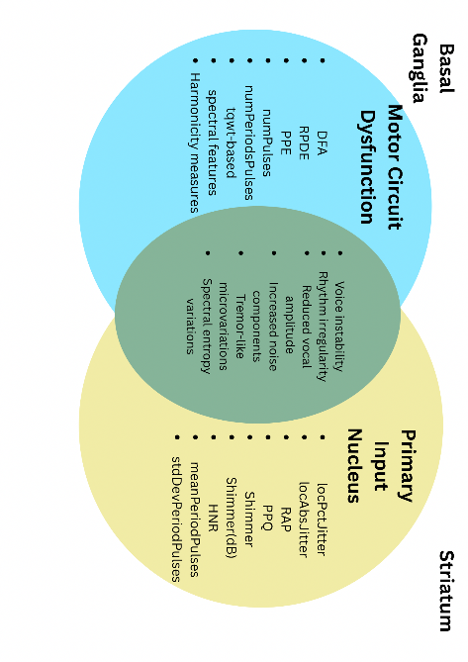
Fig. 1. Venn diagram illustrating shared and distinct speech biomarkers associated with basal ganglia and striatal dysfunction in Parkinson’s disease.

The figure shows the connection between the basal gan- glia and the striatum in Parkinson’s disease and how their dysfunction affects speech. The basal ganglia are linked to features such as DFA (Detrended Fluctuation Analysis), RPDE (Recurrence Period Density Entropy), and PPE (Pitch Period Entropy), while the striatum influences acoustic measures like jitter, shimmer, and HNR (Harmonics-to-Noise Ratio). The overlap represents common speech abnormalities such as voice instability and rhythm irregularity.
Recent advances in machine learning have created auto- mated systems which analyze speech signals to detect Parkin- son’s disease. Most research studies assess predictive accu- racy as their main objective but their results do not deliver sufficient understanding of neurophysiological processes. The evaluation of new quantum machine learning techniques lacks proper experimental controls and their performance assessment remains unclear when compared to conventional methods. The researchers developed a new evaluation framework for quan- tum machine learning models which requires both classical and hybrid models to be tested with the same set of features. The primary contribution of this work lies in providing an honest comparative analysis while explicitly linking acoustic speech features to striatal and basal ganglia dysfunction.
- Literature Review
Approximately 70 to 90 percent of patients with Parkinson’s disease experience speech problems which represent the most common and medically important symptoms of their condition. The primary vocal characteristics of acoustic abnormalities include diminished vocal strength and unchanging pitch and breathiness together with unclear speech production. Vasquez- Correa et al. [5] conducted a detailed survey of speech biomarkers used in PD research while they demonstrated that jitter and shimmer together with harmonic-to-noise ratio (HNR) measurements serve as effective indicators for assess- ing motor timing instability and force control deficits. Tsanas et al. [6] showed that doctors can use remote speech analysis to track disease development over time because this method
detects even minor problems with vocal fold control through sustained phonation tasks. Xu et al. [7] discovered that ma- chine learning models which learn from acoustic biomarkers reached area under the curve (AUC) scores above 0.90 in all standard test datasets, which demonstrates that speech functions as a trustworthy noninvasive method for diagnosing medical conditions. Ji et al. [9] demonstrated how speech biomarkers behave differently in various subtypes because different PD phenotypes display distinct patterns of striatal dysfunction. Valarmathi et al. [10] demonstrated how acoustic perturbation features link to striatal dopamine loss because speech disorders show basic vocal modifications which result from basal ganglia motor circuit breakdown.
High-dimensional acoustic features have become more ac- cessible which creates an opportunity for classical machine learning methods to dominate Parkinson’s disease speech analysis. Xu et al. [7] showed that Support Vector Machines and Random Forests together with gradient boosting methods achieve strong classification accuracy when they use complete acoustic feature collections for training. The study demon- strated that ensemble-based models successfully managed two speech dataset challenges which involved handling correlated perturbation together with nonlinear speech characteristics. Researchers have developed deep learning methods to discover unique representation patterns through automatic learning. Sedigh Malekroodi et al. [8] used transformer-based speech representation learning to achieve better classification results than their handcrafted feature models which showed how pre- trained embeddings can effectively model complex temporal and spectral relationships. The models need extensive datasets together with heavy computational power which creates a barrier for their use in medical settings. Simone et al. [11] showed that explainable artificial intelligence (XAI) plays a vital role in neurological evaluation because black-box deep learning systems decrease both clinical understanding and system reliability. Classical machine learning models maintain their competitive edge in structured acoustic datasets because they offer better sound interpretation capabilities and need less computing power while producing consistent results.
Scientists have started to investigate quantum machine learning as a new research area which studies biomedical data in recent years. Chow [12] examined how QML can help clinical decision support systems but he showed that existing Noisy Intermediate-Scale Quantum (NISQ) systems present major obstacles because they lack sufficient qubits and their circuits can only operate at limited depths. The research conducted by Rahman and Zhuang [13] focused on developing noise-aware quantum neural networks that classify biomedi- cal signals through their studies which found that quantum circuits successfully capture nonlinear relationships but their performance depends on both feature dimensionality and op- timization methods. The research conducted by Demidik et al. [14] studied quantum kernel methods which used real- world conditions to demonstrate that aggressive dimensionality reduction methods usually resulted in decreased performance. The study conducted by Pandey and Mandal [15] assessed

hybrid quantum-classical learning systems and they found that fair testing of these systems against classical systems requires both identical feature representation and strict control of testing procedures. Current evidence fails to show that quantum methods provide consistent advantages in medical speech classification according to their theoretical benefits.
- Methodology
- Data Collection
The study employs speech recordings which were collected from people who have Parkinson’s disease and from healthy control participants. The researchers used sustained vowel phonation tasks because they help identify minor vocal fold vibration problems which motor control scientists can assess through striatal and basal ganglia examination. Each speech sample is represented by a high-dimensional numerical feature vector which contains 755 attributes including a binary class label that shows whether the disease is present or absent. The dataset shows class imbalance because Parkinson’s disease samples outnumber control samples. To preserve the natural distribution of the data and avoid introducing artificial bias, stratified sampling was applied during train–test splitting and cross-validation procedures.
- Data Preprocessing
The researchers conducted extensive data preprocessing work to achieve two objectives, which were to confirm data quality and maintain statistical validity, before they started model training. The researchers first converted all features into numerical format because machine learning algorithms needed this step to proceed. The dataset contained missing values, which affected the nonlinear features and higher-order acoustic features. The missing values were filled through median imputation, which proved effective because it handles outlier conditions that typically occur in speech data.
The researchers applied feature scaling techniques to achieve uniformity across the diverse range of feature values. The researchers used standardization to convert features into a distribution that has zero mean and unit variance, which is essential for both optimization-based and distance-based
measures. The high-dimensional representation delivers sub- stantial data about striatal and basal ganglia dysfunction but it creates problems for both computational efficiency and quantum model implementation.
Principal Component Analysis (PCA) functioned as the solution to shrink the feature space through its dimensionality reduction capability. PCA created a lower-dimensional space from the original feature set while preserving all important variance information. The researchers chose four principal components which demonstrated genuine operational limits of existing quantum computing systems because each feature dimension equates to one qubit. Importantly, PCA was applied only on training data within each validation fold and then used to transform the test data, maintaining strict separation between training and evaluation.
- Model Selection and Training
Following preprocessing and feature representation, both classical and hybrid quantum machine learning models were trained and evaluated. Classical models were first trained on the complete high-dimensional feature space to establish a strong baseline.
  - PSO-SVM: In this study, PSO-SVM is used as a linear classification model to distinguish Parkin- son’s disease speech samples from healthy controls based on extracted acoustic features. The model learns a linear decision function over the feature space.
The decision function is defined as:
$f\left(X\right)=β_{0}+\sum_{{\left\{i=1\right\}}_{i}^{\left\{n\right\}β}X_{i}}{}$ (1)
n
Where X_{i} represents the extracted speech features, and β_{i} are the learned model coefficients. The sign of f (X) determines the class label, separating Parkinson’s disease and healthy control speech samples.
  - Support Vector Machine (SVM): Support Vector Ma- chine is employed to identify an optimal separating hyperplane that maximizes the margin between Parkinson’s disease and healthy speech samples in the feature space.
The optimization objective is expressed as:
$\min{} \frac{1}{2}|w|^{2} + C \sum_{i=1}^{N}{} ξ_{i}$ (2)

algorithms used in classical machine learning models. Min- Max normalization, which bounded features into an appropri- ate range for quantum angle encoding, served as the feature

mapping technique for quantum machine learning models. All preprocessing steps were fitted exclusively on training data within each fold to prevent information leakage and ensure unbiased evaluation.
- Feature Representation and Dimensionality Reduction
We extracted 754 different acoustic speech features which enabled them to study multiple aspects of speech motor control that Parkinson’s disease impacts. The features in- clude jitter and shimmer perturbation measurements together with harmonic-to-noise ratio metrics and nonlinear dynamic features and spectral descriptors and temporal energy-based
Where w defines the hyperplane, C is a regularization pa-
rameter, and ξ_{i} are slack variables allowing margin violations.
  - Extreme Gradient Boosting (XGBoost): XGBoost is an ensemble learning approach that builds multiple decision trees sequentially, where each new tree corrects the errors of the previous ones.
The objective function is given by:
$L=\sum_{i=1}^{N}{l\left(y_{i},\hat{y_{i}}\right)}+Ω$ (3)
Where l(·) denotes the classification loss, and Ω represents a regularization term controlling model complexity.

These models were trained using stratified ten-fold cross- validation to ensure robust performance estimation. To enable a fair comparison with quantum machine learning models, the same classical models were retrained using the PCA- reduced feature space. This ablation-based approach ensures that performance differences between classical and quantum models are not attributed to unequal feature representations.
  - Quantum Feature Encoding: For hybrid quantum ma- chine learning models, the reduced speech feature vector is encoded into quantum states using angle encoding, enabling representation in a quantum feature space.
The encoding is defined as:
$|ψ(x)⟩= ⨂_\{i=1\}^\{d\} R_y(x_i) |0⟩$ (4)

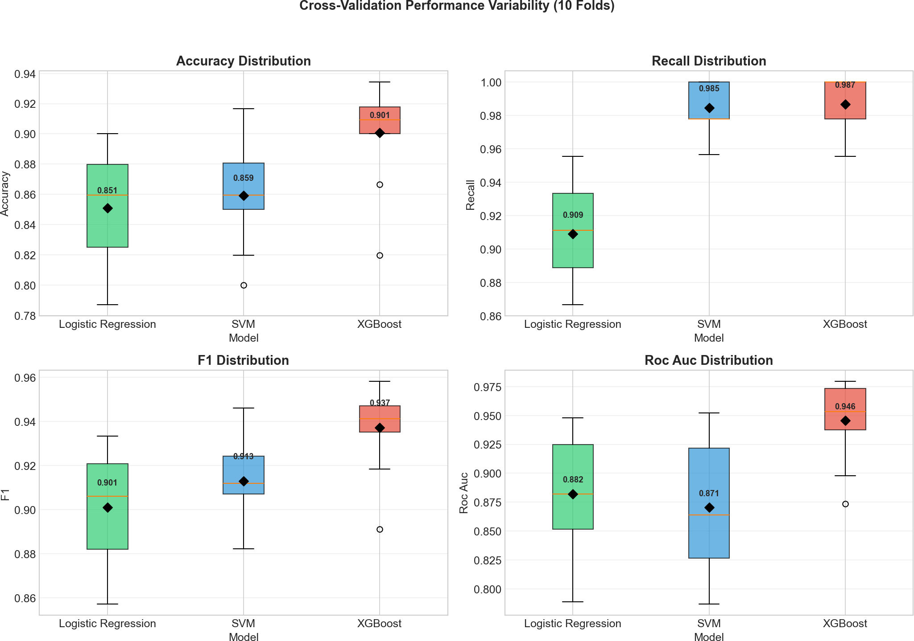

Fig. 2. Cross-validation performance variability of classical machine learning models.

Where d is the number of encoded features, and R_{y}(x_{i}) is a rotation gate parameterized by feature x_{i}.
  - Quantum Support Vector Machine (QSVM): In Quantum Support Vector Machine, a quantum kernel is used to compute similarity between samples based on quantum state overlap.
The quantum kernel is defined as:
K(x, x′) = |⟨ψ(x) | ψ(x′)⟩|2 (5)
This kernel replaces the classical kernel function used in standard SVMs.
  - Variational Quantum Classifier (VQC): The Variational Quantum Classifier utilizes a parameterized quantum circuit, where circuit parameters are optimized using a classical opti- mizer to perform classification.
The variational quantum state is expressed as:
|ψ(x, θ)⟩ = U (θ) U_{ϕ}(x) |0⟩ (6)
Where U_{ϕ}(x) encodes the input features, and U (θ) is the trainable variational circuit.
- Results and Discussion
- Classical Machine Learning Model Performance
The performance of classical machine learning models was evaluated using PSO-SVM, Support Vector Machine, and XGBoost on the test dataset. The evaluation metrics con- sidered include accuracy, recall, F1-score, and area under the ROC curve (AUC). The results obtained from the experiments are summarized in Table I.

TABLE I
Performance of Classical Machine Learning Models

Model | Accuracy | Recall | F1-Score | AUC
PSO-SVM | 0.8634 | 0.9381 | 0.9360 | 0.8483
SVM | 0.8224 | 0.9646 | 0.8898 | 0.8745
XGBoost | 0.8750 | 0.9735 | 0.9205 | 0.9274

Figure 2 presents the variability of classical machine learning model performance across ten-fold cross-validation. The box plots demonstrate the stability and consistency of accuracy, recall, F1-score, and AUC across different folds.
The results indicate that all classical models achieve strong performance in detecting Parkinson’s disease from speech features. XGBoost achieves the highest accuracy of 87.5% and the highest F1-score of 92.05%, demonstrating its effec- tiveness in modeling complex nonlinear relationships among high-dimensional acoustic features. The ensemble nature of XGBoost allows it to handle correlated features such as jitter, shimmer, and nonlinear measures more effectively than linear models.
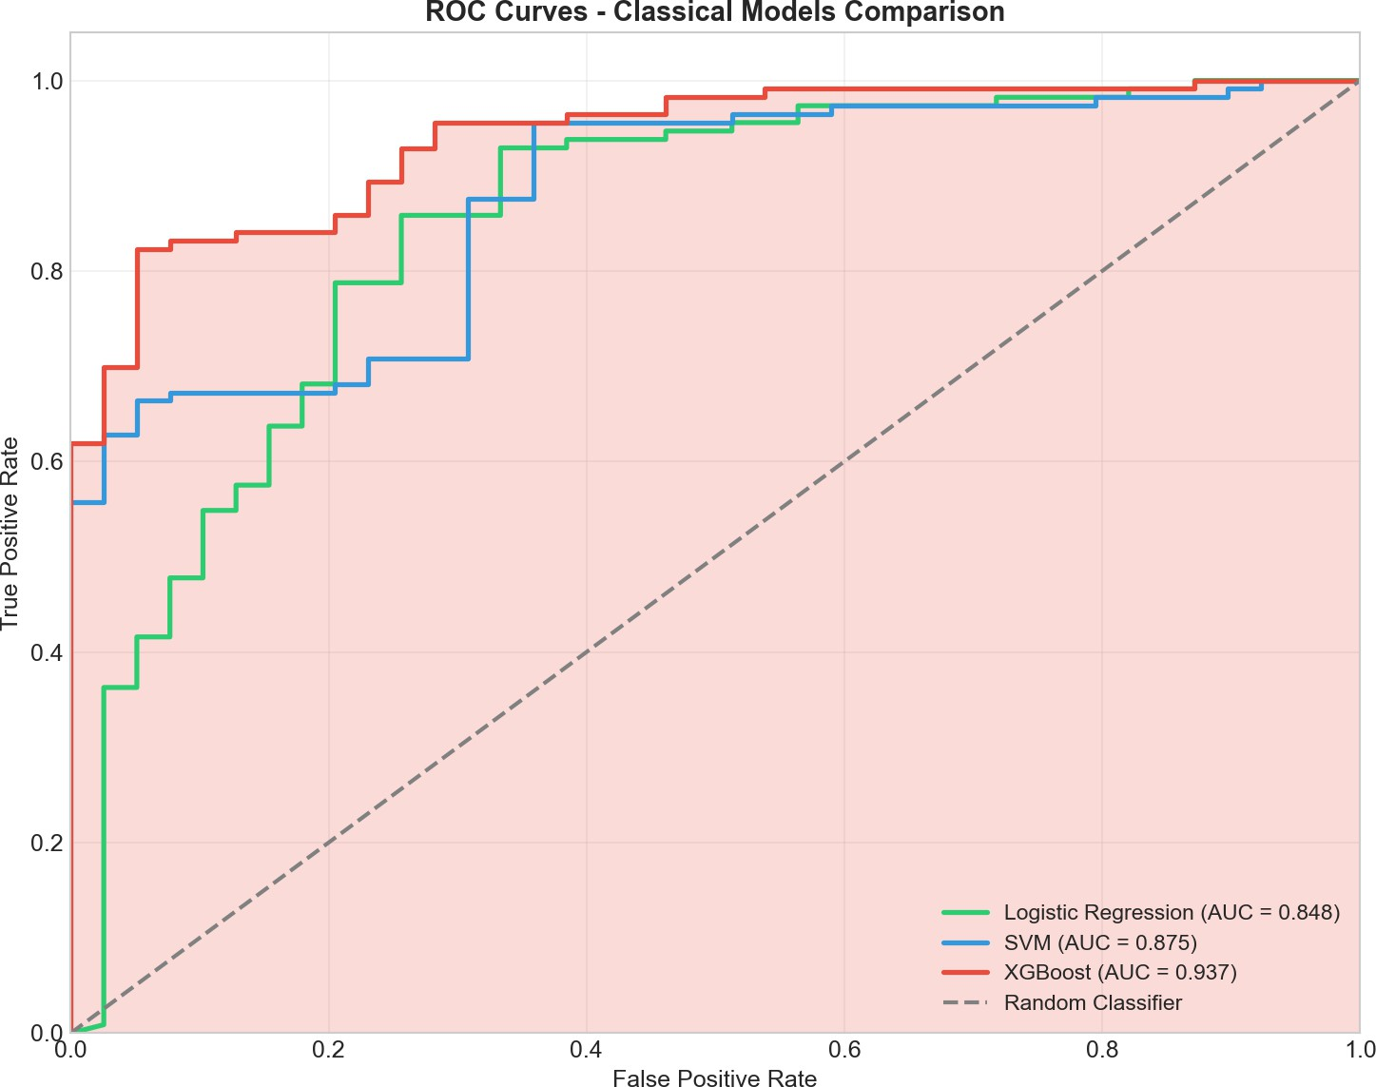

Fig. 3. ROC curves of classical machine learning models.

Figure 3 shows the ROC curves of classical machine learning models, illustrating their discriminative ability across different classification thresholds. The curves highlight the superior performance of XGBoost compared PSO-SVM and SVM.
Support Vector Machine achieves the highest recall value of 96.46%, indicating strong sensitivity in identifying Parkinson’s disease cases. This behavior is particularly desirable in clin- ical screening scenarios, where minimizing false negatives is critical. However, its slightly lower accuracy suggests that this high sensitivity comes at the cost of increased false positives. PSO-SVM provides a strong baseline with balanced performance, confirming that speech features carry statistically meaningful information related to disease status.
Overall, the classical machine learning results demonstrate

that speech-based acoustic features are highly effective for Parkinson’s disease detection and that ensemble and nonlinear models offer performance advantages when sufficient feature information is available.
- Quantum Machine Learning Model Performance
Hybrid quantum machine learning models were evaluated using Quantum Support Vector Machine (QSVM) and Varia- tional Quantum Classifier (VQC/QNN). Due to current lim- itations in quantum hardware and simulation environments, models were trained on PCA-reduced feature representations. The performance results are summarized in Table II.

TABLE II
Performance of Quantum Machine Learning Models

Model Accuracy Recall F1-Score AUC

QSVM | 0.7566 | 0.9735 | 0.8560 | 0.73
VQC / QNN | 0.7434 | 0.9735 | 0.8494 | 0.76

TABLE III
Performance of Classical Machine Learning Models with PCA

Model | Accuracy | Recall | F1-Score | AUC-ROC
PSO-SVM | 0.8146 | 0.9468 | 0.8844 | 0.8018
SVM | 0.8162 | 0.9600 | 0.8866 | 0.7836
XGBoost | 0.7966 | 0.9114 | 0.8698 | 0.8192

Tables II and III present a comparative analysis of quantum and classical machine learning models using PCA-based re- duced speech features for Parkinson’s disease detection. The quantum models (QSVM and VQC) exhibit exceptionally high recall values of 97.35%, indicating strong sensitivity in cor- rectly identifying Parkinson’s disease cases and suggesting that quantum feature mapping effectively captures core disease- related patterns within the reduced feature space. In contrast, the classical models demonstrate a more balanced overall per- formance profile: PSO-SVM achieved the highest F1- score (0.8844), reflecting a strong trade-off between precision and recall; SVM attained the highest recall (0.9608) among classical approaches; and XGBoost recorded the highest AUC- ROC (0.8192), indicating superior discriminative capability. Overall, while quantum models emphasize sensitivity, classical models provide a more balanced performance across multiple evaluation metrics, highlighting complementary strengths be- tween the two approaches..
However, quantum models exhibit lower overall accuracy and F1-score compared to classical models. QSVM achieves an accuracy of approximately 75.66%, while VQC achieves approximately 74.34%. The reduced accuracy is primarily attributed to lower specificity, indicating difficulty in distin- guishing healthy control samples under aggressive dimension- ality constraints. The approximate AUC values further confirm moderate discriminative capability, with VQC showing slightly higher AUC than QSVM.
These results reflect current limitations of quantum machine learning, including restricted feature dimensionality, shallow
circuit depth, and optimization challenges, rather than short- comings of the speech features themselves.
- Comparative Discussion and Clinical Interpretation
The research demonstrated distinct and understandable pat- terns when comparing classical machine learning methods with quantum machine learning methods. The research showed that classical models achieved better accuracy and F1-score results when trained on all available features, which demon- strated the necessity of detailed high-dimensional acoustic data for accurate Parkinson’s disease identification. The reduction in performance observed in quantum models is consistent with the necessity of aggressive dimensionality reduction imposed by current quantum computing constraints.
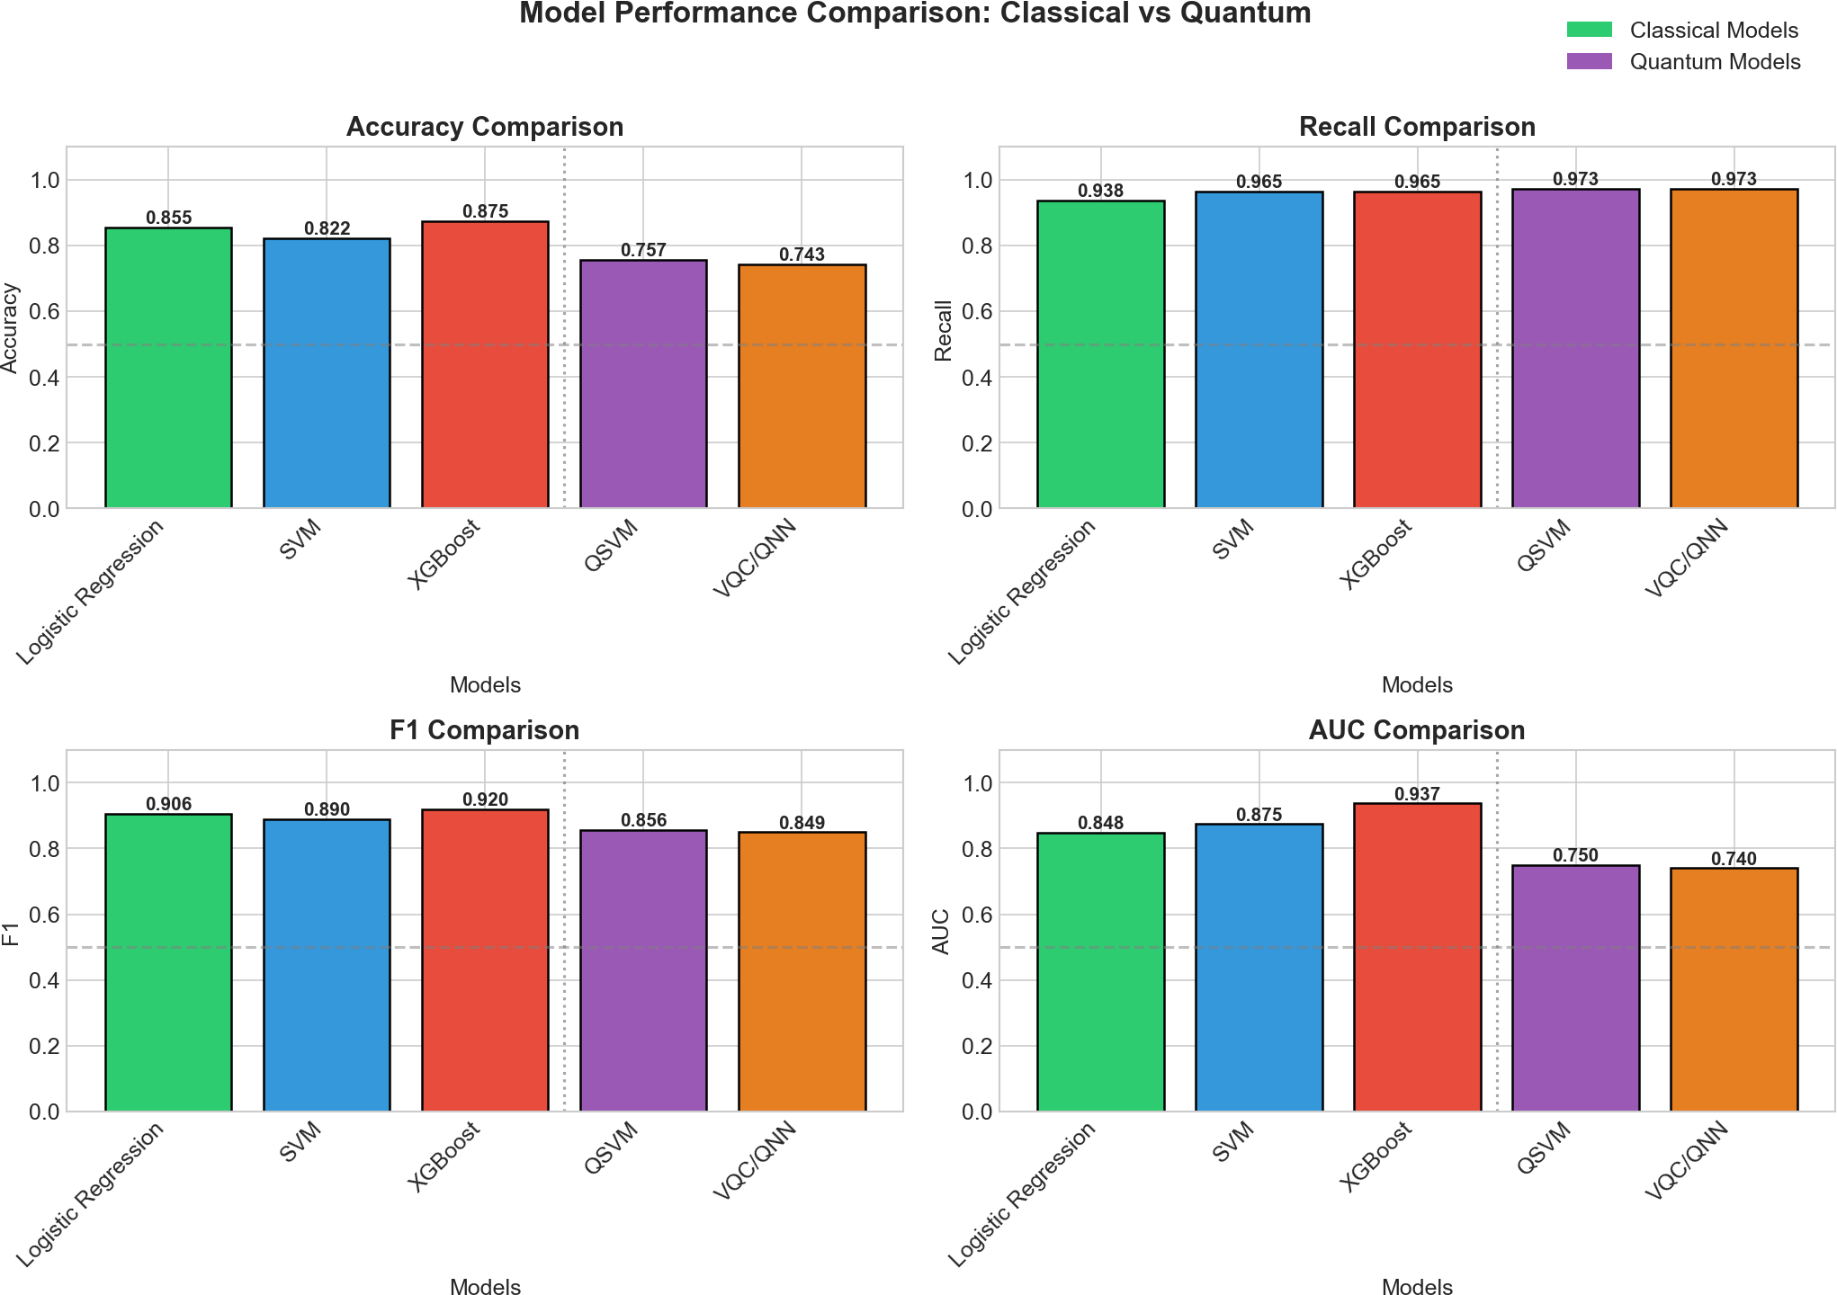

Fig. 4. Performance comparison between classical and quantum models.
Figure 4 compares the performance of classical and quan- tum machine learning models using accuracy, recall, F1- score, and AUC metrics. The comparison highlights perfor- mance differences arising from dimensionality reduction and model constraints. Despite lower accuracy, quantum models exhibit recall values comparable to or even exceeding those of classical models. The study demonstrates that quantum models can accurately identify Parkinson’s disease but fail to distinguish between sick and healthy speech samples. The results demonstrate that the test results are useful for initial screening tests because they effectively detect patients despite their need for further testing.
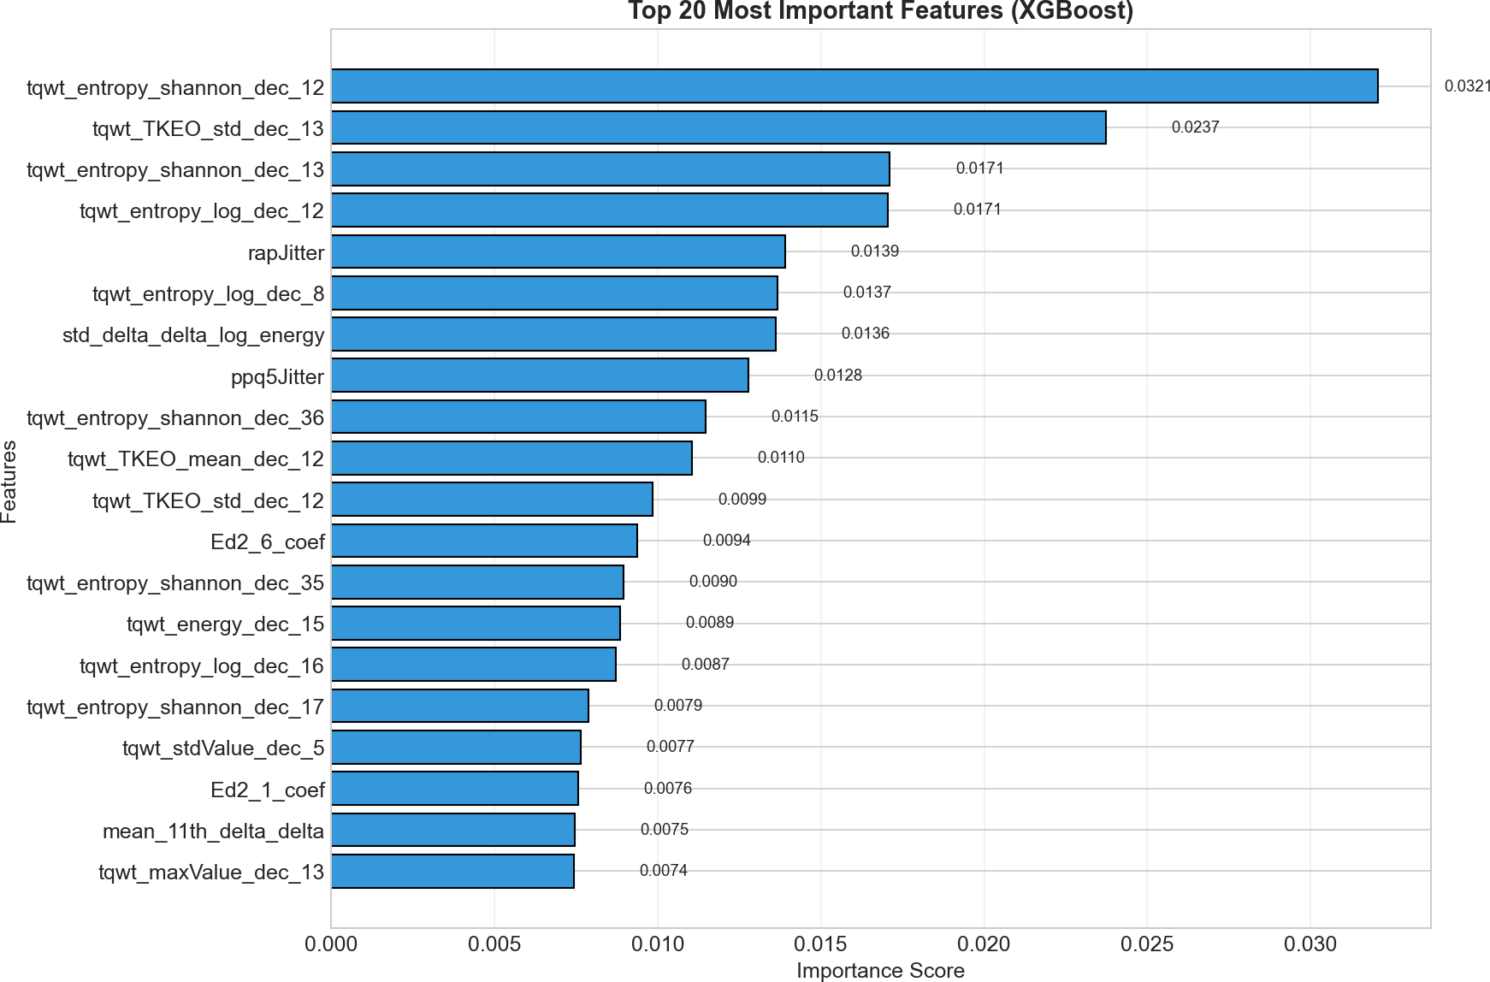

Fig. 5. Feature importance of top speech features using XGBoost.
Figure 5 shows the top speech features identified by the XGBoost model based on importance scores. Perturbation

and entropy-related features dominate, indicating strong as- sociation with striatal and basal ganglia motor dysfunction. Importantly, the separation of classical and quantum results into distinct tables allows for transparent interpretation without overstating quantum advantages. The findings demonstrate that, under current technological constraints, classical machine learning remains more suitable for practical deployment in speech-based Parkinson’s disease assessment. At the same time, quantum machine learning shows promise as an ex- ploratory approach, warranting further investigation as quan- tum hardware and algorithms mature.

- Conclusion and Future Scope
The researchers developed a speech-based computational system which enables Parkinson’s disease analysis through investigation of acoustic characteristics which indicate stri- atal and basal ganglia dysfunction. The team extracted 754 speech features which they assessed through traditional ma- chine learning techniques and their hybrid quantum machine learning models. The results demonstrate that speech signals contain meaningful information related to motor timing and force regulation deficits characteristic of Parkinson’s disease. Classical machine learning models trained on the full fea- ture space achieved strong performance, with ensemble-based methods such as XGBoost providing the highest accuracy and F1-score. The use of speech-based methods for disease detection demonstrates their effectiveness through high recall results which all traditional models show. The hybrid quantum models tested with PCA feature restriction achieved high sensitivity results but showed decreased accuracy because of existing limitations in their feature dimensionality and circuit expressivity and optimization capabilities. The research demonstrates through its adopted fair comparison method that the performance decline in quantum models because of ag- gressive dimensionality reduction also affects classical models which experience identical restrictions. Feature importance analysis confirms that perturbation-based measures such as jitter and shimmer play a dominant role, consistent with known
striatal and basal ganglia motor control deficits.
Future work will focus on increasing the framework to connected and spontaneous speech, incorporating multimodal biomarkers, and applying explainable AI techniques to im- prove clinical interpretability. As quantum hardware matures, future studies can explore richer feature representations and deeper quantum circuits to reassess the potential of quantum machine learning in neurological assessment.

References

- V. R. Patheda, G. Laxmisai, G. Bv, S. P. Siddique Ibrahim, and S. Selva Kumar, “A robust hybrid CNN+ViT framework for breast cancer classification using mammogram images,” IEEE Access, 2025. DOI: 10.1109/ACCESS.2025.3563218.
- S. K. Reehana and S. P. Siddique Ibrahim, “Multi-class spectral–spatial temporal pyramid network and multi-class classifier-based cardiovascu- lar disease classification,” Frontiers in Physiology, vol. 16, 2025. DOI: 10.3389/fphys.2025.1650134.
- S. P. Siddique Ibrahim, A. Das, N. Gaurav, L. P. Mishra, and P. Kanyal, “Healthcare analytics: Data mining techniques on electronic health records (EHR) to build a predictive model for early disease diag- nosis,” in Proc. 2025 Int. Conf. Sustainable Communication Networks and Application (ICSCN), 2025, pp. 1618–1625. DOI: 10.1109/IC- SCN67106.2025.11308699.
- S. P. Siddique Ibrahim, K. B. S., V. S. B., J. Naru, and N.
L. T., “Predicting kidney damage in hypertensive patients using machine learning,” in Proc. 2025 Int. Conf. Engineering Inno- vations and Technologies (ICoEIT), 2025, pp. 1199–1204. DOI: 10.1109/ICoEIT63558.2025.11211665.
- J. C. Vasquez-Correa, T. Arias-Vergara, and J. R. Orozco-Arroyave, “Speech biomarkers of Parkinson’s disease: Advances and open chal- lenges,” Biomedical Signal Processing and Control, vol. 92, p. 105120, 2024. DOI: 10.1016/j.bspc.2023.105120.
- A. Tsanas, M. A. Little, and L. O. Ramig, “Remote speech anal- ysis for monitoring Parkinson’s disease progression,” IEEE Re- views in Biomedical Engineering, vol. 17, pp. 98–111, 2024. DOI: 10.1109/RBME.2024.3369012.
- Y. Xu, J. Wang, H. Li, and Z. Chen, “Speech-based biomarkers for early Parkinson’s disease detection: Advances in acoustic anal- ysis and machine learning,” IEEE Transactions on Neural Systems and Rehabilitation Engineering, vol. 33, pp. 112–126, 2025. DOI: 10.1109/TNSRE.2025.3459123.
- M. Sedigh Malekroodi, T. Bocklet, and B. Schuller, “Transformer- based speech representation learning for Parkinson’s disease detec- tion,” Computer Speech & Language, vol. 84, p. 101595, 2025. DOI: 10.1016/j.csl.2024.101595.
- Y. Ji, L. Zhang, and J. R. Orozco-Arroyave, “Subtype-aware Parkinson’s disease speech analysis using graph-based machine learning,” Pattern Recognition, vol. 148, p. 110072, 2025. DOI: 10.1016/j.patcog.2024.110072.
- S. Valarmathi, R. Kumar, and G. Prasad, “Linking acoustic speech features to striatal dopamine depletion in Parkinson’s dis- ease,” Frontiers in Neuroscience, vol. 19, p. 1298347, 2025. DOI: 10.3389/fnins.2025.1298347.
- C. Simone, F. Hirsch, and E. No¨th, “Explainable artificial intelligence for speech-based neurological disorder assessment,” IEEE Journal of Biomedical and Health Informatics, vol. 29, no. 3, pp. 1032–1043, 2025. DOI: 10.1109/JBHI.2025.3447812.
- J. M. Chow, “Quantum machine learning for clinical decision support systems: Opportunities and limitations,” Nature Digital Medicine, vol. 8, p. 42, 2025. DOI: 10.1038/s41746-025-01042-9.
- M. Rahman and J. Zhuang, “Noise-aware quantum neural networks for biomedical signal classification,” IEEE Access, vol. 13, pp. 45712–45725, 2025. DOI: 10.1109/ACCESS.2025.3559214.
- A. Demidik, M. Schuld, and N. Wiebe, “Quantum kernel methods for biomedical data under realistic constraints,” Quantum Machine Intelligence, vol. 7, no. 1, p. 9, 2025. DOI: 10.1007/s42484-025-00109-
6.
- A. Pandey and S. Mandal, “Hybrid quantum–classical learning frame- works for healthcare data analytics,” Quantum Information Processing, vol. 24, no. 3, p. 87, 2025. DOI: 10.1007/s11128-025-04087-2.

